Student:Iancu Daiana

**Group:30431**

**Assignment 2**

Table of Contents

1. Requirements Analysis 3

1.1 Assignment Specification 3

1.2 Functional Requirements 3

1.3 Non-functional Requirements 3

2. Use-Case Model 3

3. System Architectural Design 3

4. UML Sequence Diagrams 3

5. Class Design 3

6. Data Model 3

7. System Testing 3

8. Bibliography 3

1. Requirements Analysis

# Assignment Specification

Design and implementation of an application for tracking the laboratory activity of the Software Design laboratory. The application must have two types of users: teacher and student.

# Functional Requirements

The application has the following functional requirements, divided into two categories according to each type of user:

The teacher can perform the following operations:

* Login
* CRUD on students. When you create a student, a 128 characters token is created. Using that token student should be able to register. Teacher will send the token by email manually. For each student we should track: email address, full name, group (ex. 30431) and top 1 hobby.
* Can add/edit/delete Laboratory classes. For each class we should track: laboratory number (1-14), date, title, curricula for what are the topics presented in that lab and a long description with the laboratory text (should accept html).
* CRUD on attendance for each lab.
* CRUD on assignments. Some of the laboratory will have assignments: for each assignment we must track the name, deadline and a long description with the assignment text.
* Grade the submitted assignments. It should also be possible to regrade the assignment.
* Get the list of grades for all students for a given assignment.

The student can perform the following operations:

* Register using the token generated by the teacher.
* Login with the username and password.
* View a list of laboratory classes. Also view a filtered list: student inserts a keyword and that keyword is searched in the curricula and long description.
* View the assignments for a laboratory class.
* Create an assignment submission. Here, students should be able to insert a link to a git repository and a short remark for the teacher.

# Non-functional Requirements

* The data will be stored in a database.
* Use the MVC architectural pattern to organize the application.
* API design should be RESTful.
* Use and ORM (Hibernate / Entity framework) to access the database
* Use dependency injection to inject Services in Controllers and Repositories in Services
* Install and use Swagger to call the APIs.
* Connection string should be stored in a separate config file

2. Use-Case Model

*Use case: create Submission*

*Level: user-goal level*

*Primary actor: student*

*Main success scenario: successful submission*

*Extensions: unsuccessful submission*

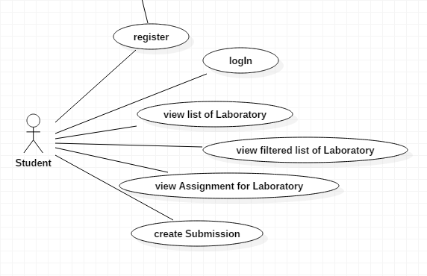

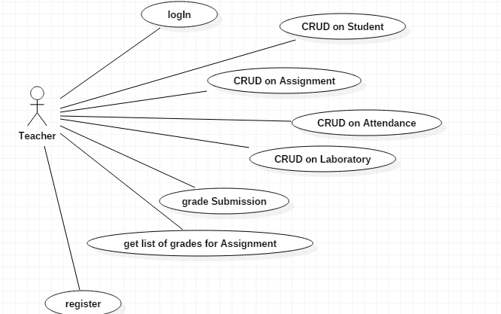

3. System Architectural Design

**3.1 Architectural Pattern Description**

The used architectural pattern is Model-View-Controller.

The MVC pattern is used to divide an application into 3 parts, as the name suggests it:

* the model-containing the functionality and data
* the view-displays information to the user
* the controller-handles the input from the user

This pattern allows efficient code reuse.

In the package diagram, the split of the application in a MVC manner can be observed.

In this assignment, the view part was omitted. For the view, Swagger was used.

**3.2 Diagrams**

Package diagram

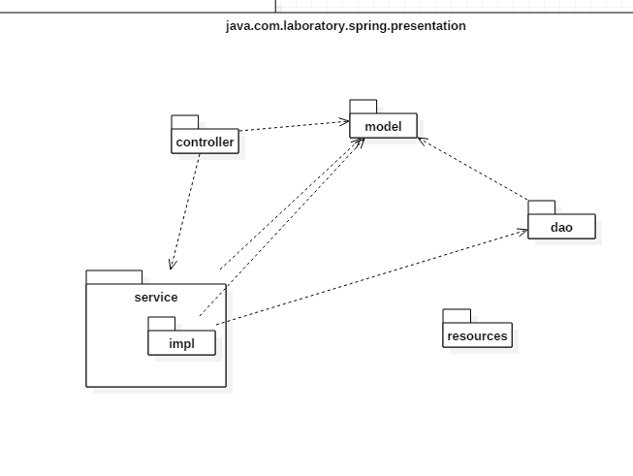

Component Diagram

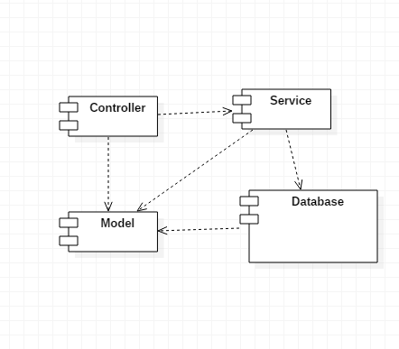

Deployment Diagram

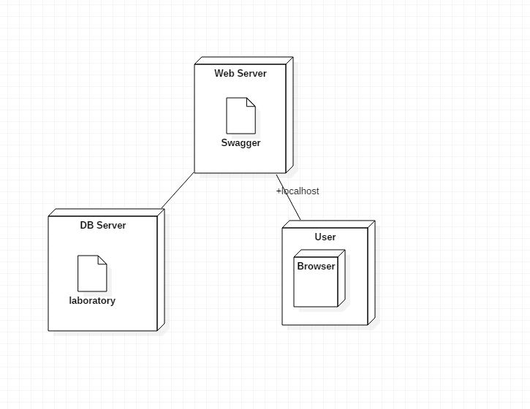

4. UML Sequence Diagrams

The scenario for which the sequence diagram below is created is: student log in

Student LogIn

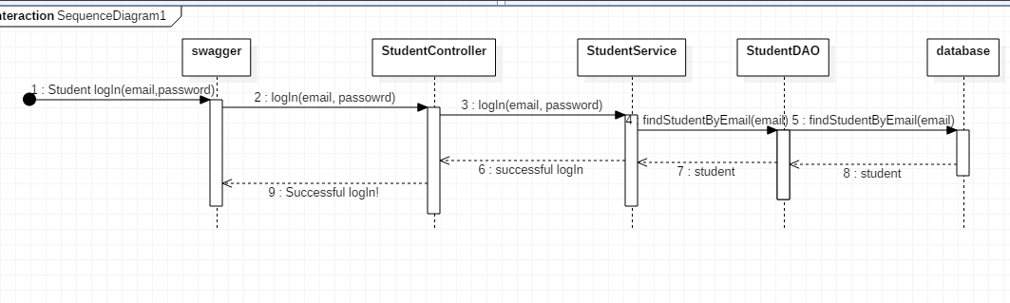

5. Class Design

**5.1 Design Patterns Description**

**5.2 UML Class Diagram**

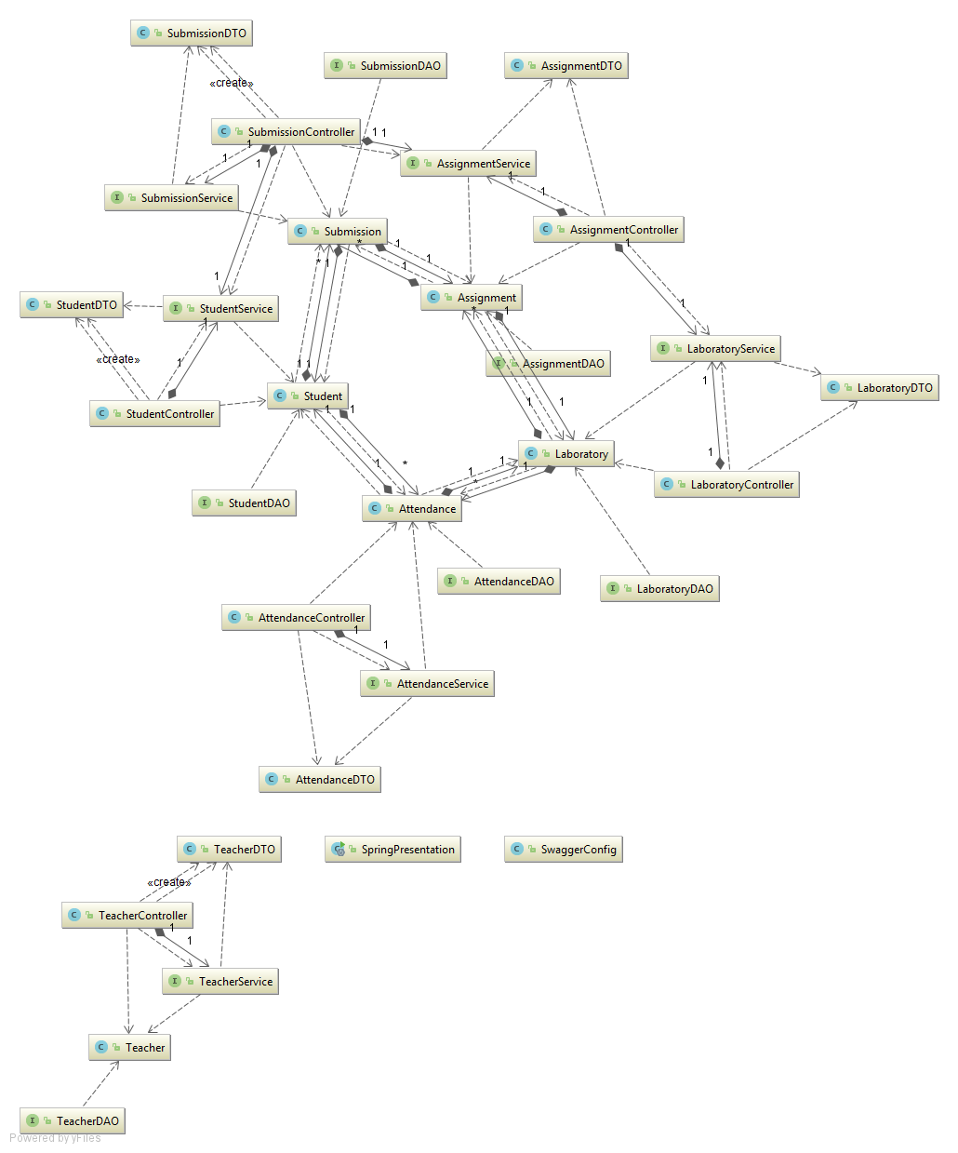

6. Data Model

The following classes represent the model:

* Student
* Teacher
* Laboratory
* Attendance
* Assignment
* Submission

In the images below, we can observe the attributes that these classes have.

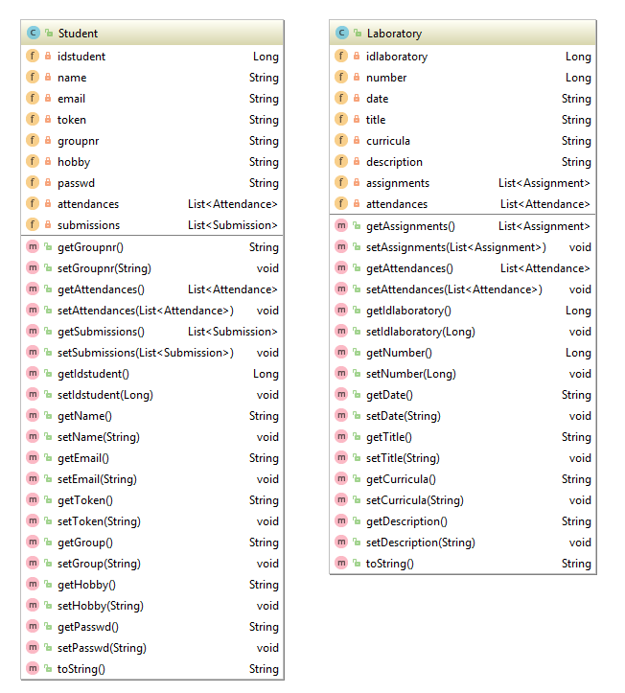

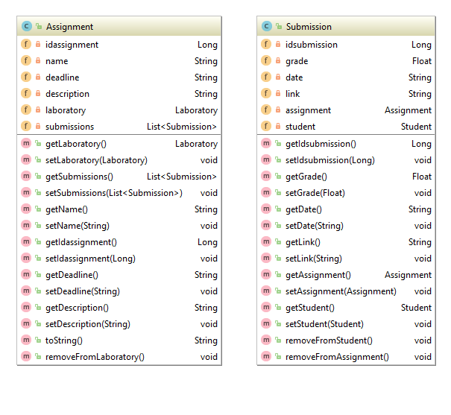

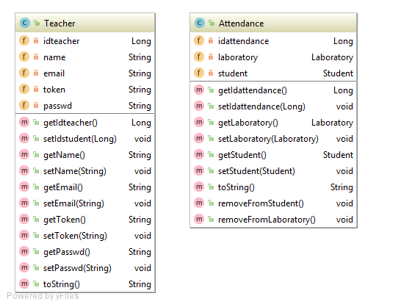

7. System Testing

The testing was done for each flow database-model-service-controller.

For example, for the StudentController, there were tests performed for each of the methods, using correct as well as incorrect examples. For instance, when trying to add a student with the same e-mail, nothing happens.

8. Bibliography